Tab 1 Data at position 0.1m after collimator 1
Project | I | ERR | N
1 | 2.12328e+010 | 2.434e+008 | 66920
2 | 2.29927e+010 | 2.55512e+007 | 6.84181e+006
3 | 2.29927e+010 | 2.55512e+007 | 6.84181e+006
4 | 1.61748e+010 | 4.18194e+006 | 7.65966e+007

Charts 1 to 4 correspond to the 4 projects above. (L_monitor、PSD_monitor、Divergence_monitor、xdiv_I、ydiv_I、x_I、y_I in turn)
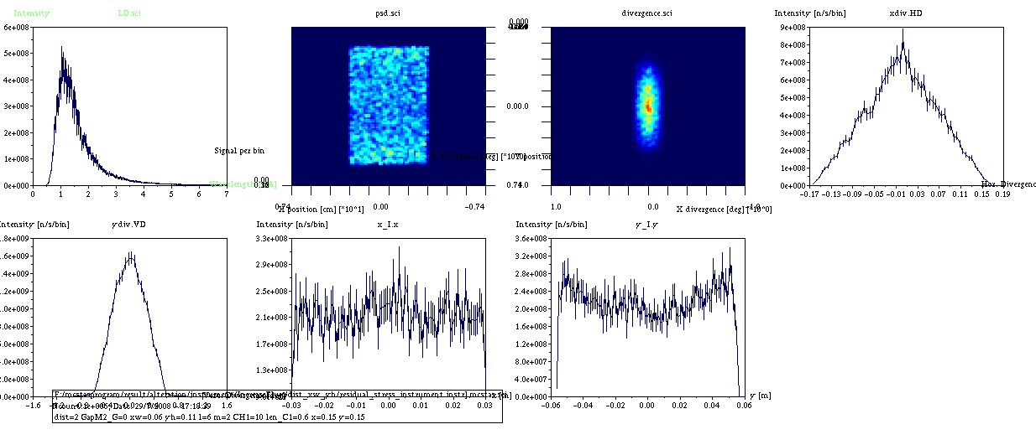
Chart 1 Focusing project 1
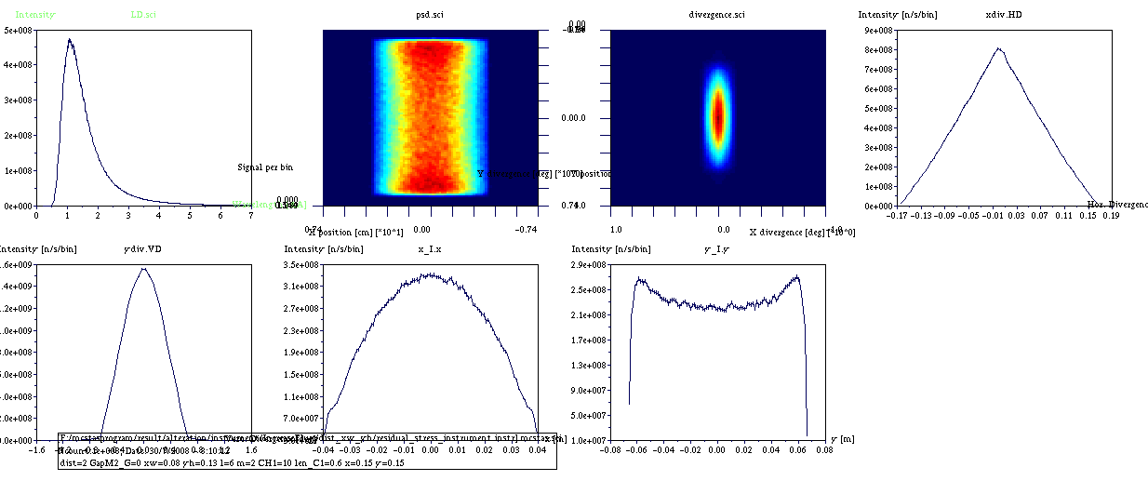
Chart 2 Focusing project 2
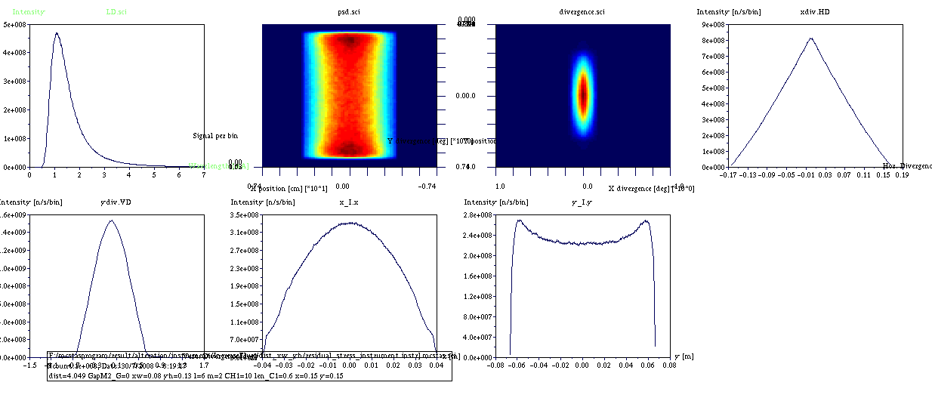
Chart 3 Focusing project 3
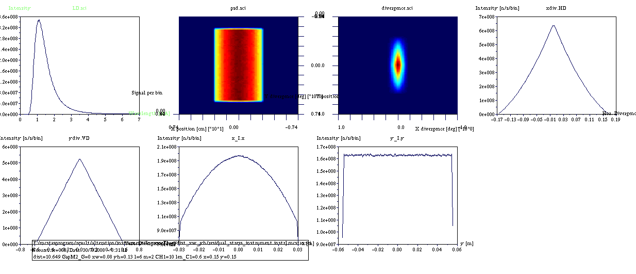
Chart 4 Focusing project 4

